Sacaton Cooperative Station and Pima Cotton: 1908-1924
Pima-Maricopa Irrigation Project Education Initiative
2002-2003

Restoring water to ensure the
continuity of the Akimel O’otham
and Pee Posh tradition of agriculture

Re

In its second year as a cooperative experimental farm, the Sacaton station began conducting research that would revolutionize the cotton industry in the United States. A few acres of Egyptian long staple cotton was planted at the cooperative station as part of the United States Department of Agriculture’s (USDA) Cotton Research Center in Sacaton. It was at the time “the largest single field [of Egyptian long-staple cotton] in the New World.” Imported from Egypt, researchers T.H. Kearney and W.A. Peterson “acclimatized” and “improved” the cotton to Southwestern desert soils. The Cotton Research Center was soon convinced that the plant could be easily adapted to the dry Arizona heat and the fine, sandy loam soil of the reservation and would be “particularly valuable” since there was a growing demand for long-staple cotton, justifying the expense of sending it “long distances to market” in the east.
Part 37
Both the USDA and the Indian Service were particularly interested in the possibility of new crops being grown in a reservation environment lacking water. The government agencies immediately made plans to educate the Pimas, “who promise by virtue of their industry, patience and honesty,” to play a role in “establishing the cotton industry.” Both the Indian Service and the USDA were convinced that, if they could demonstrate the success of the long staple cotton to the Pimas, they would “be able to grow small fields of cotton themselves, to be picked by the old men and the women, while the younger men picked the crops grown by the white settlers in adjoining regions.”
The USDA imported Mitafifi cotton from Egypt in 1900, believing it could be adapted to similar climates in the American Southwest. A.J. Chandler was the first to grow the cotton in the Salt River Valley when he planted it on his south Mesa farm, in 1902. In 1907, “plant breeding” work began at Sacaton and Bard, California, to see if the plant could be improved. The following year, a variety called “Yuma” was segregated from Mitafifi. By 1909, the Sacaton experimental farm had 12 acres planted in the Yuma variety of Egyptian cotton, harvesting about 5,000 pounds of “very fine quality” cotton. In 1910, Kearney identified one “outstanding different plant” of Yuma cotton and Pima long staple cotton was born.
Pima cotton was more productive, had a larger boll, longer fibers and better lint quality than other cottons. Two leading factors in developing the cotton were boll weevil infestations in the cotton industry in the southern United States and the growing demand for long staple cotton. By 1911, Sacaton station had 20 acres of Pima cotton in production, with several Pima farmers growing an additional 8-10 acres with seed furnished by the cooperative station. While the Pimas had pledged to grow 60 acres of cotton that year, they were restricted because of allotment work, which cast doubts among the Indians as to whether or not they would be able to harvest the crop in the fall that might then be on land assigned to another Pima farmer. Nonetheless, a number of Pima farmers pledged “to plant cotton as soon as they know where their farms are to be located.”
The long-staple Egyptian cotton from the Sacaton cooperative station was called “the Pima variety” due to its engineering in Sacaton. Despite the small quantities grown, the cotton sold for .28 cents per pound in 1911, a nickel more than “the best imported Egyptian” cotton. Agency Superintendent H.C. Russell observed there was “practically an unlimited demand” for Pima cotton and that the outlook for growing it on the reservation was “very hopeful.” An abundance of labor—including many Papago who, Russell opined, “would be glad to have the chance of working for the Pima farmers”—was available to harvest the cotton. While the Pimas did not immediately begin growing cotton in large quantities, the Indian Service’s goal was that it would “someday become extensive on this reservation.”
After 5 years of testing, Pima cotton was “proven superior to its parent, Yuma” cotton. Several hundred acres of Pima cotton was planted in the Salt River Valley in 1916 and, by 1918, “practically the entire cotton acreage” in the Salt River Valley was Pima cotton. Long staple cotton increased in demand for use in automobile tires and as a substitute for flax in making airplane fabric. A rapid increase in the number of automobiles necessitated a less expensive and more durable means of making tires. World War One in Europe generated a shortage of linen, which created an opportunity for producers of long-staple cotton. Not only was Pima long staple cotton a substitute for linen, but it could also be grown in large quantities on new farms across the Southwest. By 1920, the Pima cotton industry was well established, with more than 180,000 acres growing in the Salt River Valley and over 2,600 acres growing on the reservation. By the mid 1920s, Arizona farmers led the nation in Pima long staple cotton production. Pima cotton remained the “only variety of American-Egyptian cotton grown in Arizona” until 1933.
So successful was the development of Pima cotton that Goodyear Tire and Rubber Company of Ohio purchased several thousand acres of land in the Salt River Valley to produce Pima cotton for use in its automobile tires. A farm in south Chandler near Casaba Station on the Arizona Eastern Railway grew tons of cotton for use in Goodyear tires. Many Pimas went to work at the farm, which eventually gave rise to the village of Goodyear in District Four. By 1920, the “Pima variety” was officially called Pima long-staple cotton.
The Sacaton cooperative station was enlarged in 1917 with the addition of a seed farm a half-mile west of Sacaton. The seed farm was intended to serve as an extension of the research station and produce cash crops to support the research facility. It was also established to provide the Pimas with “adequate supplies of pure seed of the new and improved varieties originated or developed” at the farm for use on the reservation. At the cooperative farm, the Bureau of Plant Industry continued to perform plant spacing, row width, time of planting, amount of irrigation and time between irrigation experiments to determine the optimal culture of Pima cotton.
The seed farm was also used to grow a variety of fruits, alfalfa and vegetables. The road that led to the farm soon became known as “Seed Farm Road” and is today one of the major east-west streets in Sacaton. So successful was the cotton work at Sacaton that Commissioner of Indian Affairs Cato Sells projected putting “into cultivation 50,000 acres [of cotton] in one tract of desert land on the Pima Reservation.”
The Sacaton cooperative station and the adjacent seed farm tested and grew hundreds of plants, distributing them across the Southwest and even back to Egypt (where the Egyptian long-staple cotton continued to undergo genetic engineering). It also proved “beneficial to the Indians in the matter of furnishing pure seed and encouraging them to diversify their products, and to produce more fruit, vegetables, etc.” By the 1920s, a number of Pimas had taken first prize in cotton production at both the Arizona State Fair and the Pinal County Fair.
The Sacaton cooperative station was designed to demonstrate to the Pimas that they could grow a variety of crops using available land and water resources in the most advantageous manner. While many crops were tested and grown, the overall struggle remained the same for the Gila River Indian Community: insufficient water. By the early 1920s, the cooperative station was fully functioning, allotment of the reservation was accomplished, new crops were being grown and two diversion dams built. But the Pima and Maricopa still lacked an adequate water supply. Until an adequate supply of water could be made available, agriculture as a way of life would be hard to retain on the reservation.
Plant Diagram of the Sacaton Cooperative Station, 1921∗


Plant Diagram for the Sacaton Seed Farm, 1921∗
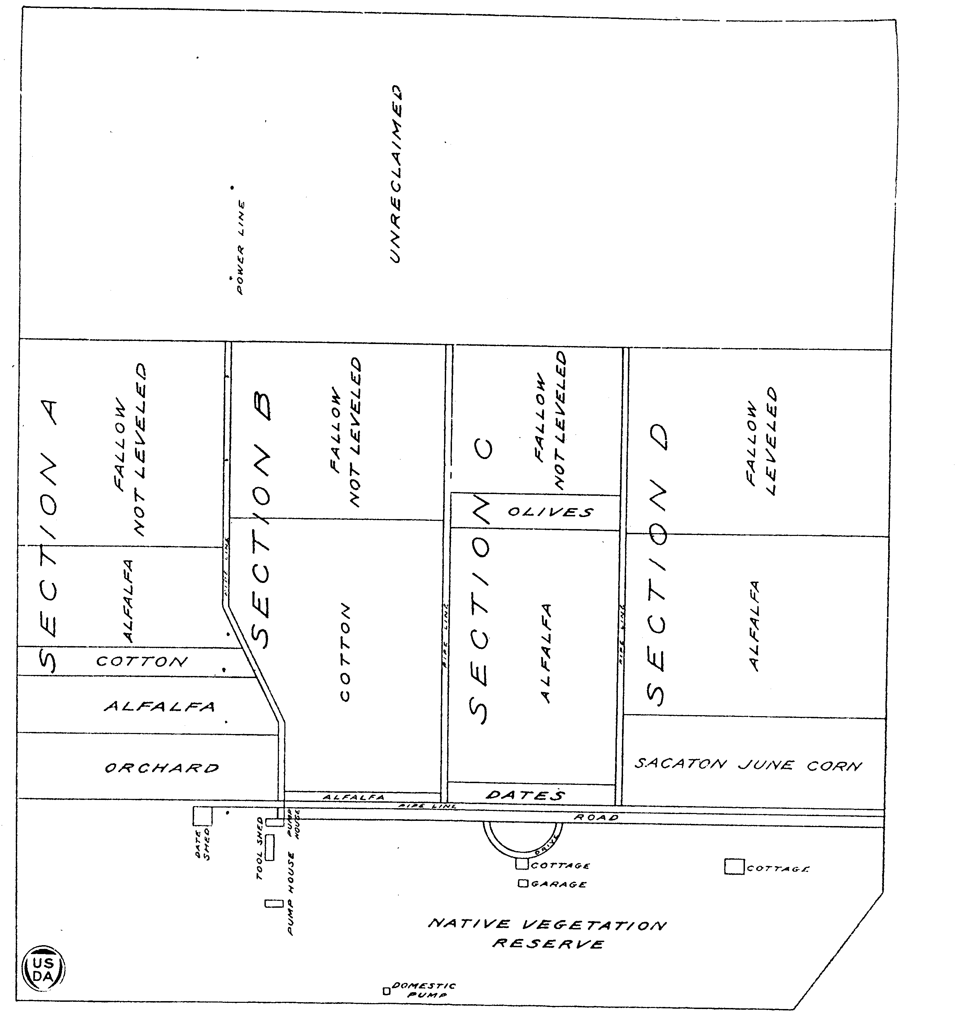
∗ “Crops tested at the Cooperative Testing Station, Sacaton, Arizona,” United States Department of Agriculture, Department, Circular No. 277 (Washington DC: GPO, September 1923).

Teacher Plan for “Sacaton Cooperative Farm and Pima Cotton: 1908-1924”
Objectives

Students will be able to:

- Discuss the historic development of Pima long staple cotton.

- Explain the purpose of the seed farm established as part of the Sacaton Cooperative Station in 1917.
Terms to know and understand

- Mitafifi
- Acclimatized
- Industry
- Long-staple cotton
- Seed farm
Critical Thinking:

- How is your life impacted by the cotton industry? Think in terms of your clothing, home furnishings, farm equipment, family livelihood, etc. How has cotton impacted American culture as a whole? How about Pima-Maricopa culture? How has it impacted the clothes we wear? Are there new ways of using cotton that scientists have not yet thought of? Brainstorm possible new uses.
Activities:

- The Pima-Maricopa Irrigation Project has a team of agricultural development specialists who are researching traditional Pima-Maricopa crops and potentially new commercially grown crops that could be grown within the Community. Invite one of P-MIP’s agricultural development specialists into your classroom to discuss specific research projects that are on-going. They are prepared to speak on topics such as the importance of agriculture, careers in agriculture, what it takes to farm today, traditional and native crops of the Gila River Indian Community, and ways to integrate agriculture into the school curriculum. They can be reached at (520) 562-6700.

- Have students research the differences between long staple and short staple cotton. What differences are found in the fibers and textures of the two cottons? Research Goodyear Tire Company and learn how the automobile industry was impacted by the development of Pima long staple cotton. How has Pima cotton been genetically engineered in recent years? A good website to visit is Supima. Their web address is www.supima.com. They are based at 4141 East Broadway Phoenix, Arizona 85040. They can be reached by telephone at (602) 437-1364.
About P-MIP

The Pima-Maricopa Irrigation Project is authorized by the Gila River Indian Community to construct all irrigation systems for the Community. When fully completed, P-MIP will provide irrigation for up to 146,330 acres of farmland. P-MIP is dedicated to three long-range goals:
- Restoring water to the Akimel O’otham and Pee Posh.
- Putting Akimel O’otham and Pee Posh rights to the use of water to beneficial use.
- Demonstrating and exercising sound management to ensure continuity of the Community’s traditional economy of agriculture.

